Bangladesh University of Professionals



Faculty of Science and Technology
Department of Information & Communication Technology (ICT)

Course Title: Industrial Training

Course Code: ICE-3211

Submitted by

Section – A, Batch: BICE – 2022

Name: Nasrat Jahan
ID:2254901061
Walton ID: IA-539
Submission Date: 09.05.2026

Assignment 2
Folder Structure
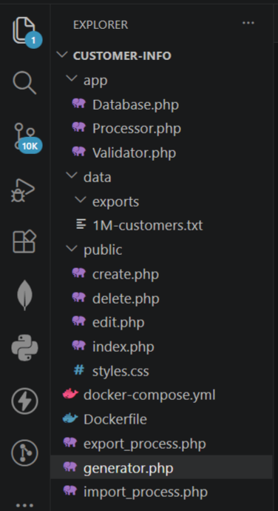

Docker-compose.yml
version: '3.8'

services:
# The Web & CLI Application
app:
build: .
container_name: customer_app
ports:
- "9000:80"
volumes:
- .:/var/www/html
depends_on:
- db
- redis
networks:
- customer_network

# MySQL Database (Requirement #2, #4)
db:
image: mysql:8.0
container_name: customer_db
environment:
MYSQL_ROOT_PASSWORD: root
MYSQL_DATABASE: customer_db
volumes:
- db_data:/var/lib/mysql
networks:
- customer_network

# Redis Cache (Requirement #10 - High Performance Service)
redis:
image: redis:alpine
container_name: customer_redis
networks:
- customer_network

networks:
customer_network:
driver: bridge

volumes:
db_data:

Dockerfile
FROM php:8.2-apache
# Install System Dependencies
RUN apt-get update && apt-get install -y \
libpq-dev \
libonig-dev \
libzip-dev \
zip \
unzip

# Install PHP Extensions
# pcntl is REQUIRED for Requirement #11 (Multithreading/Forking)
RUN docker-php-ext-install pdo pdo_mysql pcntl mbstring zip

# Install Redis Extension for caching
RUN pecl install redis && docker-php-ext-enable redis

# Enable Apache Mod Rewrite
RUN a2enmod rewrite

# Set Working Directory
WORKDIR /var/www/html

# Expose Port 80
EXPOSE 80

1M-customers.txt
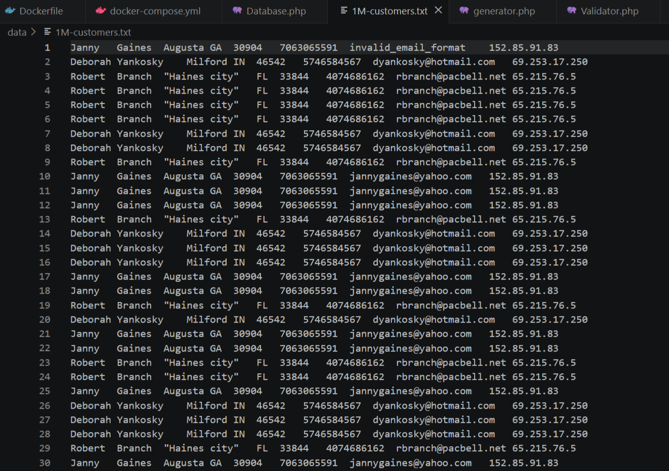
Commands
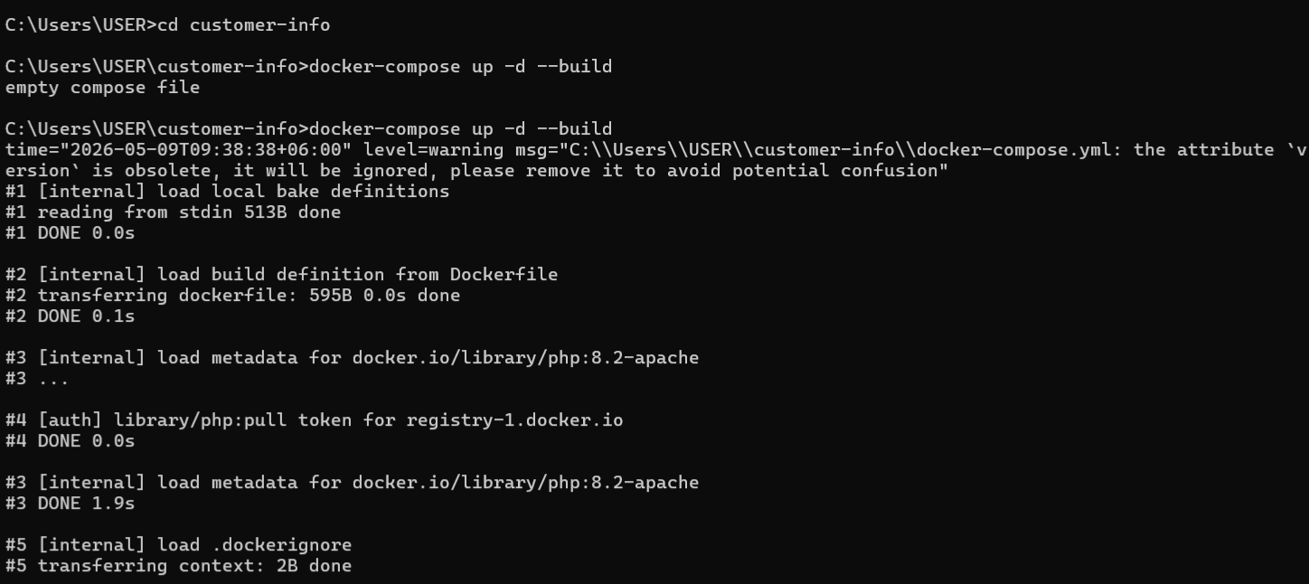
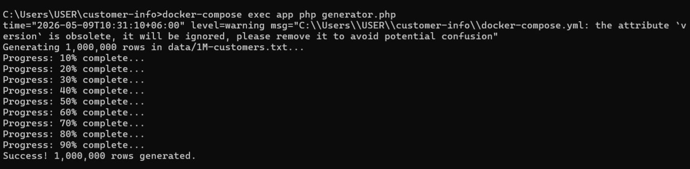

Output
